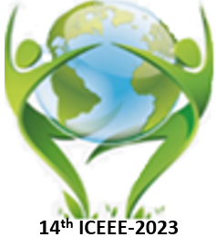 | The 14th ICEEE-2023 Online  International Annual Conference on  “Global Environmental Development & Sustainability: Research, Engineering & Management”
TITLE
Author’s NAME¹
Workplace, city, country, e-mail, telephone
Abstract
Concise and factual. It should state briefly the purpose of the research, the principal results and major conclusions.
100 to 300 words;
No figures; No references
Sub-sections if needed.
The abstract should be written in English;
Deadline for sending the abstract is October 15. 2023
Font: Times New Roman, Size: 11, Alignment: Justified

Keywords: not more 6 words
Biography
Fresh  Photo | Font: Times New Roman, Size: 11, Alignment: Justified  Not more 100 work

